My first Ecommerce project

start: 04/10/20

Set things up

Create the ROOT folder somewhere on your PC/mac: call it STORE

Open it using VS code.

1.make sure you have git & node.js latest version

Just download the msi file. Check version by >>node -v

<https://nodejs.org/en/download/current/>

>>npm i -g npm

<https://www.npmjs.com/>

2. VS code extensions:

* ES7 react /redux/graphQL/ react-native snippits: rcc , rafce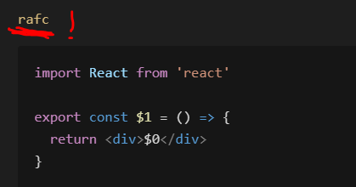
* Bracket pair colorizer
* Auto rename tag -changing opening tac with the closing tag in jsx and html
* Javascript ES6 snippits: clg +enter=> console.log()
* Prettier

FRONT END-Start with create-react-app

Open Terminal at root level:

>>npx create-react-app frontend (yes! Npx!) :will create it inside frontend folder.

>>cd frontend

>>npm start //will run our frontend (react) web dev server

// ctrl +c will terminate the front end dev server.

Go to package.json=> check out the scripts and dependencies

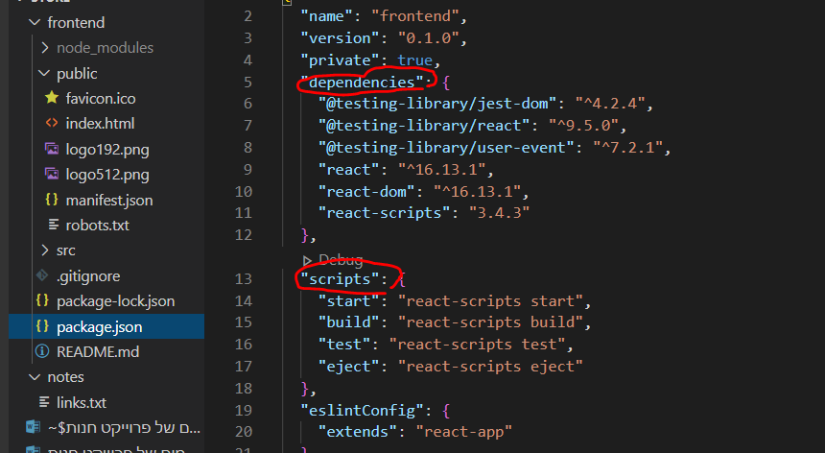

React data flow:

react is a single page application

public-> index.html : the browser initially will read it.

It doesn’t have much in it except for a div with an id attribute “root”, this is the react entry point from:

src-> index.js which contains:

import App from './App';

ReactDOM.render(

  <React.StrictMode>

    <App />

  </React.StrictMode>,

  document.getElementById('root')

);

Src -> app.js is a component containing data that will be rendered to the DOM .

Public-> index.html : clean it a little bit:

<!DOCTYPE html>

<html lang="en">

  <head>

    <meta charset="utf-8" />

    <link

      rel="icon"

      href="%PUBLIC\_URL%/Polyverse\_logo\_ico"

      type="image/x-icon"

    />

    <meta name="viewport" content="width=device-width, initial-scale=1" />

    <meta name="theme-color" content="#000000" />

    <meta

      name="description"

      content="POLYVERSE- makes your music feel different"

    />

    <link rel="apple-touch-icon" href="%PUBLIC\_URL%/logo192.png" />

    <link rel="manifest" href="%PUBLIC\_URL%/manifest.json" />

    <title>Polyverse Music</title>

  </head>

  <body>

    <noscript>You need to enable JavaScript to run this app.</noscript>

    <div id="root"></div>

  </body>

</html>

will add a description in the tab and a small logo photo.

**Src->**

Files to clean:

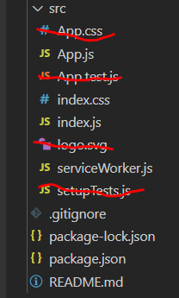

Src-> app.js => lets clean it so the app won’t run what we’ve just deleted:

Did you notice the **JSX** syntax? Same as html with slight different.

Lets clear this code :

 <div className="App">

      <header className="App-header">

        <img src={logo} className="App-logo" alt="logo" />

        <p>

          Edit <code>src/App.js</code> and save to reload.

        </p>

        <a

          className="App-link"

          href="https://reactjs.org"

          target="\_blank"

          rel="noopener noreferrer"

        >

          Learn React

        </a>

      </header>

    </div>

Let’s make it an arrow function component:

import React from 'react'

const App = () => {

  return (

    <div>

      <h1>Hi!</h1>

    </div>

  )

}

export default App

src -> index.css =>we will also delete all the content in this file

GIT- version control

Make sure you have the latest version of git.

Terminate the front end dev server by ctrl + c.

Go in windows to the frontend folder: right click ->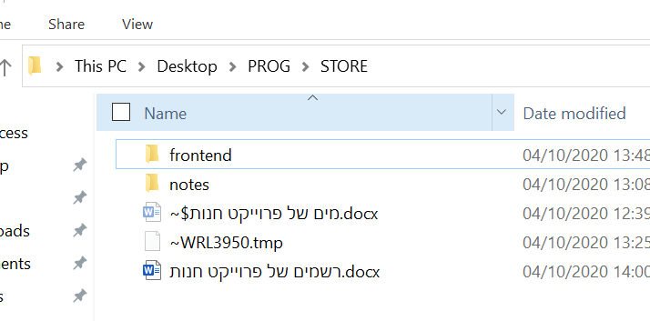

Bit bash here -> git bash cli opens ->

>> ls -a

//you will see all the hidden folders under the frontend folder and specificly the /.git

We want to delete it!

>> rm -rf .git

Now go to the  **.gitignore**  file and move it so it will be under frontend folder!

This file will let to define which folders/ files you don’t want to move to your github repository:

Basically node\_modules folder (because you may just download the repo and use

>> npm i to install all dependencies.)

We will make sure you add =>

# dependencies

node\_modules -> this one is the frontend node modules.

node\_modules/ -> this one is the backend node modules.

# misc

.env

.env ->a file in which we will store some global variables that may contain sensitive information such as pay pal API key , mongoDB URI – we don’t want GitHub users to see.

**Initializing GitHub Repository:**

In the terminal :

We want to be on the root folder -> STORE (right now you should be on frontend).

>> cd ..

>> git init

>> git add . 🡺 stage all files!

>> git status 🡺 check which files got staged

>> git commit -m 'React first setup'

* Go to github and open a new reposetory

>> git remote add origin “repo URL…”

>>git push -u origin master

Next time in order to push new changes:

That’s is!

Now Relaunch the React dev server:

>>cd frontend

>>npm start

React-Working on the Front End.

Src-> create new folder -> compponents

Here all the components files will be.

Create inside components folder -> Header.js

Header.js 🡺 is our first component file! Naming conventions 🡺 upper case first letter + .js.

Now use the 🡺 rafce ->code snippet shortcut

So you will create a react arrow functional component syntax with export expression.

import React from 'react'

const Header = () => {

    return (

        <div>

        </div>

    )

}

export default Header

in the same manner create Footer.js file.

Render some text in both files.

App.js 🡺 import the footer and header components and render them:

import React from 'react'

import Header from './components/Header'

import Footer from './components/Footer'

const App = () => {

  return (

    <div>

      <Header />

      <main>

        <h1>this is some text</h1>

      </main>

      <Footer />

    </div>

  )

}

export default App

Using Bootswatch theme & React Bootstrap

\*you may also use Material UI

\*styled components.

\*CSS

<https://bootswatch.com/>

download a template as you wish 🡺 bootstrap.min.css

drag the file to frontend-> src.

Index.js 🡺

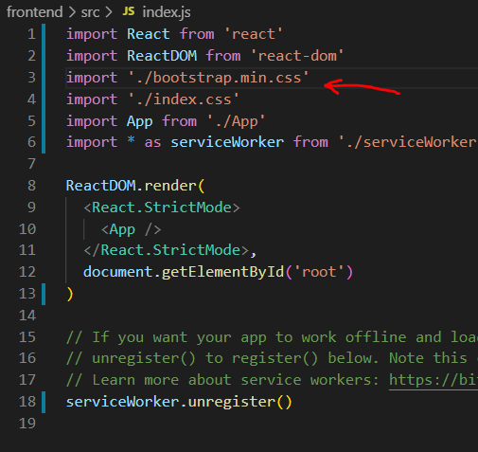

You may see that the font has change.

Now let’s install Bootstrap:

Terminal:

Make sure you on frontend folder.

>> npm I react-bootstrap

Go back to App.js

Import container from bootstrap and use it to render h1, will move the text 20% to the center of the page:

import React from 'react'

import { Container } from 'react-bootstrap'

import Header from './components/Header'

import Footer from './components/Footer'

const App = () => {

  return (

    <div>

      <Header />

      <main>

        <Container>

          <h1> Poly-this is some text</h1>

        </Container>

      </main>

      <Footer />

    </div>

  )

}

export default App

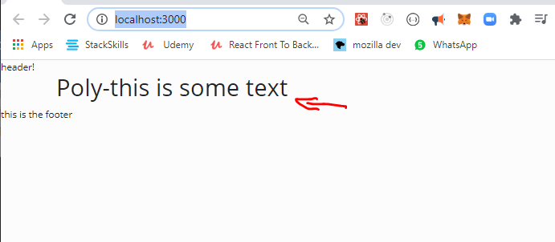

Footer.js 🡺 we want to center the text in the footer and push it to the bottom of the page.

We will use bootstrap and CSS at index.css file

Import some more bootstrap components: Row & Col.

import React from 'react'

import { Container, Row, Col } from 'react-bootstrap'

const Footer = () => {

  return (

    <footer>

      <Container>

        <Row>

          <Col className='text-center py-3'>Copyright &copy; Polyverse </Col>

        </Row>

      </Container>

    </footer>

  )

}

export default Footer

lets explain 🡺

<Col className='text-center py-3'>Copyright &copy; Polyverse </Col>

className='text-center py-3' 🡺 we use className to pass the visual inputs to bootstrap.

Text center + padding top and bottom.

&copy;  🡺 is the copyright © sign

Index.css 🡺 will push the text down.

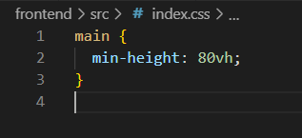

And the result :

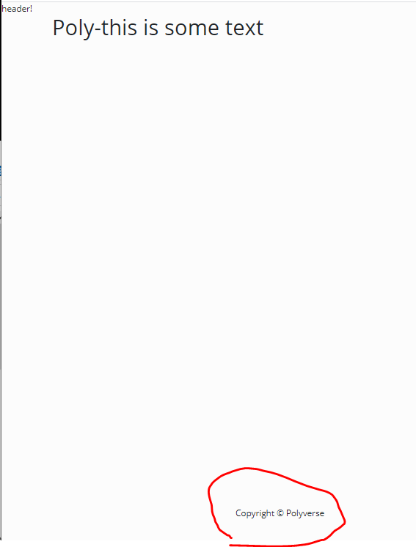

**Creating a NAV BAR**

Header.js🡺

<https://react-bootstrap.github.io/components/navbar/>

choose from the documentation a navbar code example and add it to the Header component:

import React from 'react'

import { Navbar, Nav, Container } from 'react-bootstrap'

import mainLogo from './mainlogo.png'

const Header = () => {

  return (

    <header>

      <Navbar bg='light' expand='lg' collapseOnSelect>

        <Container>

          <Navbar.Brand href='/'>

            <img

              src={mainLogo}

              className='d-inline-block align-top'

              alt='Polyverse logo'

            />

          </Navbar.Brand>

          <Navbar.Toggle aria-controls='basic-navbar-nav' />

          <Navbar.Collapse id='basic-navbar-nav'>

            <Nav className='ml-auto'>

              <Nav.Link href='/cart' varient='dark'>

                <h2>Cart</h2>

              </Nav.Link>

              <Nav.Link href='/login' varient='dark'>

                <h2>Sign In</h2>

              </Nav.Link>

            </Nav>

          </Navbar.Collapse>

        </Container>

      </Navbar>

    </header>

  )

}

export default Header

* Make sure you add your logo.png to the components folder. And import it to the component.

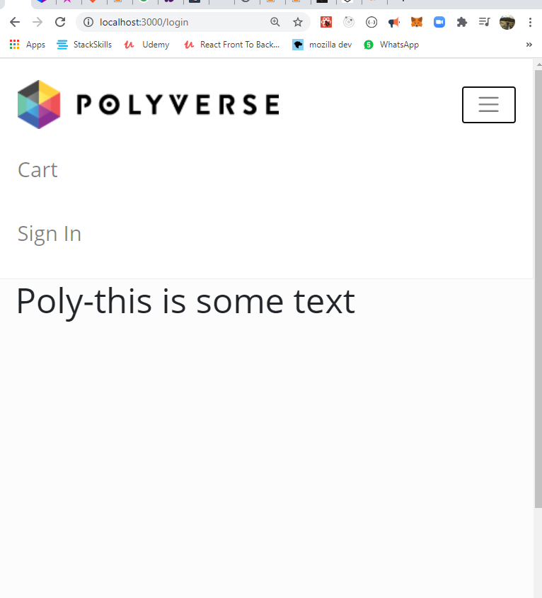

Adding icons with font awesome CDN:

Go to: <https://cdnjs.com/>

Search for font awesome CDN:

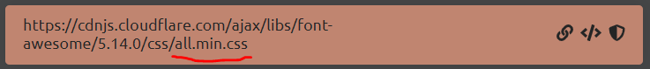

Copy Link Tag </>

And paste in public 🡺 index.html

Above the title tag :

 <link

      rel="stylesheet"

      href="https://cdnjs.cloudflare.com/ajax/libs/font-awesome/5.14.0/css/all.min.css"

      integrity="sha512-1PKOgIY59xJ8Co8+NE6FZ+LOAZKjy+KY8iq0G4B3CyeY6wYHN3yt9PW0XpSriVlkMXe40PTKnXrLnZ9+fkDaog=="

      crossorigin="anonymous"

    />

    <title>Polyverse Music</title>

Lets search for icons for shopping cart & login:

Implement it in the navbar code:

 <Nav className='ml-auto'>

              <Nav.Link href='/cart' varient='dark'>

                <h4>

                  {' '}

                  <i className='fas fa-shopping-cart'></i> Cart

                </h4>

              </Nav.Link>

              <Nav.Link href='/login' varient='dark'>

                <h4>

                  <i className='fas fa-user-astronaut'></i> Sign In

                </h4>

              </Nav.Link>

 </Nav>

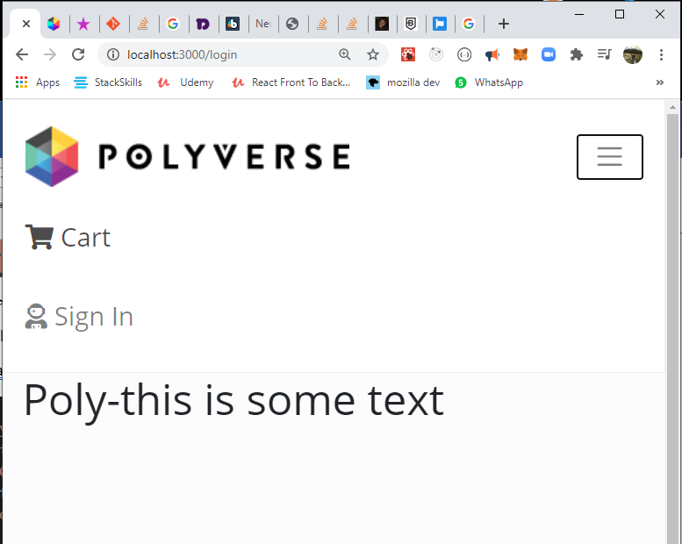

Website main content area:

Now lets create some space between the web content and the nav bar with bootstrap className=’py-4’

Src->App.js 🡺

const App = () => {

  return (

    <div>

      <Header />

      <main className='py-4'>

        <Container>

          <h1> Poly-this is some text</h1>

        </Container>

      </main>

      <Footer />

    </div>

  )

}

export default App

**Adding products:**

Frontend->public 🡺 create a new folder “images” : add to it all your products photos.

Frontend -> src 🡺 create a new file : products.js .

add to it products: an array of objects.

const products = [

  {

    \_id: '1',

    name: 'Airpods Wireless Bluetooth Headphones',

    image: '/images/airpods.jpg',

    description:

      'Bluetooth technology lets you connect it with compatible devices wirelessly High-quality AAC audio offers immersive listening experience Built-in microphone allows you to take calls while working',

    brand: 'Apple',

    category: 'Electronics',

    price: 89.99,

    countInStock: 10,

    rating: 4.5,

    numReviews: 12,

  }]

Lets start working on our shop:

Src🡺 new folder “screens” 🡺 new file HomeScreen.js

Import products (notice it is lower case import!!!)

and bootstrap Row & Col

Render all product names to the dom.

<Col sm={12} md={6} lg={4} xl={3}>

🡺 a syntax for what will be the column size on different screens (small, medium, large …)

import React from 'react'

import { Row, Col } from 'react-bootstrap'

import products from '../products'

const HomeScreen = () => {

  return (

    <>

      <h1> Latest Products </h1>

      <Row>

        {products.map((product) => (

          <Col sm={12} md={6} lg={4} xl={3}>

            <h3>{product.name}</h3>

          </Col>

        ))}

      </Row>

    </>

  )

}

export default HomeScreen

add the component to the App.js 🡺

import HomeScreen from './screens/HomeScreen'

const App = () => {

  return (

    <div>

      <Header />

      <main className='py-4'>

        <Container>

          <HomeScreen />

        </Container>

      </main>

      <Footer />

    </div>

  )

}

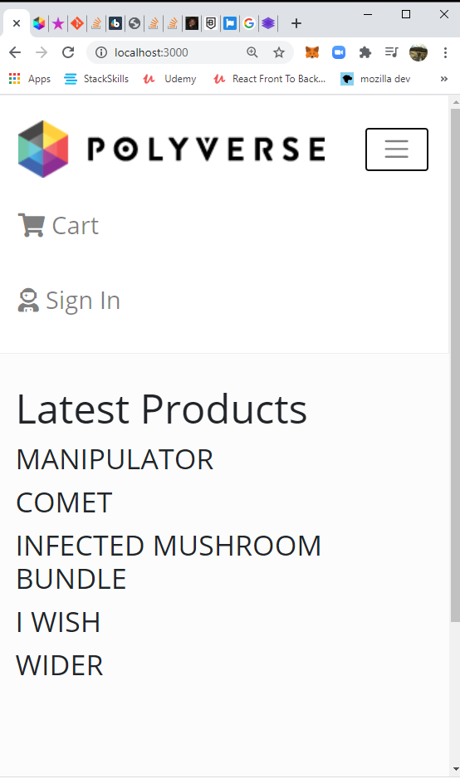

**Product CARD component:**

**Src -> components 🡺 new file ProductCard.js**

import React from 'react'

import { Card } from 'react-bootstrap'

const ProductCard = ({ product }) => { //destructure product from the prop

  return (

    <Card className='my-3 p-3 rounded zoom'> // margin padding round corners & zoom on hover!!!

      <a href={`/product/${product.\_id}`}> //soon we will change it to react router Link

        <Card.Img src={product.image} variant='top' />

      </a>

    </Card>

  )

}

export default ProductCard

**In src->screens-> HomeScreen.js make sure you :**

import ProductCard from '../components/ProductCard'

and add the card component under the product name and pass it a prop=> of the current product being looped in the map method.

 <h1> Latest Products </h1>

      <Row>

        {productsCat.map((product) => (

          <Col sm={12} md={6} lg={4} xl={3}>

            <ProductCard product={product} />

          </Col>

        ))}

      </Row>

**Zoom on hove Card :** we added a className of zoom to the card in ProductCard.js

Index.css 🡺

.zoom {

  transition: transform 0.2s; /\* Animation \*/

  margin: 0 auto;

}

.zoom:hover {

  transform: scale(1.1); /\* (10% zoom)\*/

  z-index: 1;

}

**Product card.js:**

Lets design the structure of the card: an image, name of product, star ratings, number of reviews and price.

Add an import to Ratings.js – this component renders the star icons ratings.

import React from 'react'

import { Card } from 'react-bootstrap'

import Ratings from './Ratings'

const ProductCard = ({ product }) => {

  //destructure props

  return (

    <Card className='my-3 p-3 rounded zoom'>

      <div>

        <a href={`/product/${product.\_id}`}>

          <Card.Img src={product.image} variant='top' />

        </a>

      </div>

      <Card.Body>

        <a href={`/product/${product.\_id}`} className='text-decoration-none'>

          <Card.Title as='div' className='text-info'>

            <p class='font-weight-bold h4'>{product.name}</p>

          </Card.Title>

        </a>

        <Card.Text as='div' className='my-3 text-dark h5'>

          <Ratings value={product.rating} text={product.numReviews} /> //pass two props: the rating and number of reviews!

        </Card.Text>

        <Card.Text as='h3'>${product.price}</Card.Text>

      </Card.Body>

    </Card>

  )

}

export default ProductCard

components-> Ratings.js 🡺 this component will return stars rating and beneath it a text of number of reviewers.   
CHECK OUT THE STAR ICON AT <https://fontawesome.com/icons?d=gallery&q=star>

FIND HALF STAR ICON ALSO!

import React from 'react'

const Ratings = ({ value, text }) => {

  return (

    <div className='rating'>

      <span>

        <i

          className={

            value >= 1

              ? 'fas fa-star'

              : value >= 0.5

              ? 'fas fa-star-half-alt'

              : 'far fa-star' //empty star

          }

        ></i>

      </span>

      <span>

        <i

          className={

            value >= 2

              ? 'fas fa-star'

              : value >= 1.5

              ? 'fas fa-star-half-alt'

              : 'far fa-star'

          }

        ></i>

      </span>

      <span>

        <i

          className={

            value >= 3

              ? 'fas fa-star'

              : value >= 2.5

              ? 'fas fa-star-half-alt'

              : 'far fa-star'

          }

        ></i>

      </span>

      <span>

        <i

          className={

            value >= 4

              ? 'fas fa-star'

              : value >= 3.5

              ? 'fas fa-star-half-alt'

              : 'far fa-star'

          }

        ></i>

      </span>

      <span>

        <i

          className={

            value >= 5

              ? 'fas fa-star'

              : value >= 4.5

              ? 'fas fa-star-half-alt'

              : 'far fa-star'

          }

        ></i>

      </span>

      <p>{text > 1 ? `${text} Artists reviews` : `${text} Artist review`}</p>

      {/\*may also write {text && text} \*/}

    </div>

  )

}

export default Ratings

**SO THE CARD WILL LOOK LIKE THAT :**

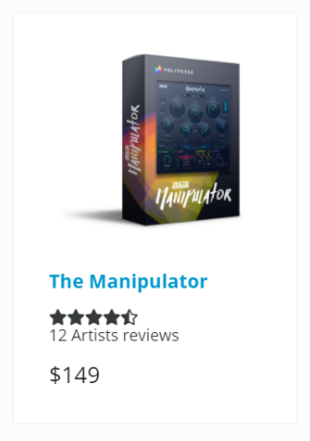

**Ratings.js 🡺**

Lets add more features:

1. Yellow color to the rating stas (as a prop that its color set by default as yellow)
2. Set up default prop method.
3. Set up propTypes to regulate the data type that we receive in the props.

import React from 'react'

import PropTypes from 'prop-types' //impt -shortcut. //import propTypes!

const Ratings = ({ value, text, starColor }) => { //star color prop!

  return (

    <div className='rating'>

      <span>

        <i

          style={{ color: starColor }} //react CSS inline style as star color prop!- make sure you code-> style ={{ }}.

          className={

            value >= 1

              ? 'fas fa-star'

              : value >= 0.5

              ? 'fas fa-star-half-alt'

              : 'far fa-star' //empty star

          }

        ></i>

      </span>

      <span>

        <i

          style={{ color: starColor }}

          className={

            value >= 2

              ? 'fas fa-star'

              : value >= 1.5

              ? 'fas fa-star-half-alt'

              : 'far fa-star'

          }

        ></i>

      </span>

      <span>

        <i

          style={{ color: starColor }}

          className={

            value >= 3

              ? 'fas fa-star'

              : value >= 2.5

              ? 'fas fa-star-half-alt'

              : 'far fa-star'

          }

        ></i>

      </span>

      <span>

        <i

          style={{ color: starColor }}

          className={

            value >= 4

              ? 'fas fa-star'

              : value >= 3.5

              ? 'fas fa-star-half-alt'

              : 'far fa-star'

          }

        ></i>

      </span>

      <span>

        <i

          style={{ color: starColor }}

          className={

            value >= 5

              ? 'fas fa-star'

              : value >= 4.5

              ? 'fas fa-star-half-alt'

              : 'far fa-star'

          }

        ></i>

      </span>

      <p>{text > 1 ? `${text} Artists reviews` : `${text} Artist review`}</p>

      {/\*may also write {text && text} \*/}

    </div>

  )

}

//set default prop

Ratings.defaultProps = {

  //set starColor (it's a component props) as yellow by default

  starColor: '#fada00',

}

//propTypes- setting the data types of the props. if conditions not met, will throw an error in consule.

Ratings.propTypes = {

  value: PropTypes.number.isRequired,

  text: PropTypes.string.isRequired,

  starColor: PropTypes.string,

}

export default Ratings

Implementing React Router!

First- install react router and react router boostrap:

Terminal :

>>cd frontend

>> npm i react- router-dom react-router-bootstrap

App.js 🡺

from this:

import React from 'react'

import { BrowserRouter as Router, Rout } from 'react- router-dom'

import { Container } from 'react-bootstrap'

import Header from './components/Header'

import Footer from './components/Footer'

import HomeScreen from './screens/HomeScreen'

const App = () => {

  return (

    <Router>

      <Header />

      <main className='py-4'>

        <Container>

          <HomeScreen />

        </Container>

      </main>

      <Footer />

    </Router>

  )

}

export default App

to this:

import React from 'react'

import { BrowserRouter as Router, Route } from 'react- router-dom' //import of react router!

import { Container } from 'react-bootstrap'

import Header from './components/Header'

import Footer from './components/Footer'

import HomeScreen from './screens/HomeScreen'

import ProductScreen from './screens/ProductScreen' //import of a new component

const App = () => {

  return (

    <Router> //must wrap the whole jsx code!

      <Header />

      <main className='py-4'>

        <Container>

          <Route path='/' component={HomeScreen} exact /> //exact because it’s the root url! There is nothing after the ‘/’

          <Route path='/product/:id' component={ProductScreen} /> // path’s id value will be a parameter because we wrote it as one -> “/:XYZ” , check the dynamic code in ProductCard.js who’s generating this path.

And ProductScreen.js as the one who needs acceses to this Quary param

        </Container>

      </main>

      <Footer />

    </Router>////must wrap the whole jsx code!

  )

}

export default App

lets make a ProductScreen component to show each product page:

screens -> ProductScreen.js

import React from 'react'

const ProductScreen = () => {

  return <div>product</div>

}

export default ProductScreen

we also now need to change the <a href> tags in the card component to react router Link component! This is the link that generates the dynamic URL with the item’s id.

components-> Productcard.js :

import React from 'react'

import { Link } from 'react-router-dom' //import Link

import { Card } from 'react-bootstrap'

import Ratings from './Ratings'

const ProductCard = ({ product }) => {

  //destructure props

  return (

    <Card className='my-3 p-3 rounded zoom'>

      <div>

        <Link to={`/product/${product.\_id}`}> //will rout us to this url.

          <Card.Img src={product.image} variant='top' />

        </Link>

      </div>

      <Card.Body>

        <Link to={`/product/${product.\_id}`} className='text-decoration-none'>

          <Card.Title as='div' className='text-info'>

            <p class='font-weight-bold h4'>{product.name}</p>

          </Card.Title>

        </Link>

        <Card.Text as='div' className='my-3 text-dark h5'>

          <Ratings value={product.rating} text={product.numReviews} />

        </Card.Text>

        <Card.Text as='h3'>${product.price}</Card.Text>

      </Card.Body>

    </Card>

  )

}

export default ProductCard

lets use react router in the NavBar

we will use react-router-bootstrap for that. Only then we may wrap the react-bootstrap components.

Why we do this anyways? Right now when we click links in the navbar the page will refresh, because react is a single page app, we don’t welcome this kind of behavior.

components-> Header.js 🡺

import React from 'react'

import { Navbar, Nav, Container } from 'react-bootstrap'

import { LinkContainer } from 'react-router-bootstrap'

import mainLogo from './mainlogo.png'

const Header = () => {

  return (

    <header>

      <Navbar bg='light' expand='lg' fixed='top' collapseOnSelect>

        <Container>

          <LinkContainer to='/'>

            <Navbar.Brand>

              <img

                src={mainLogo}

                className='d-inline-block align-top'

                alt='Polyverse logo'

              />

            </Navbar.Brand>

          </LinkContainer>

          <Navbar.Toggle aria-controls='basic-navbar-nav' />

          <Navbar.Collapse id='basic-navbar-nav'>

            <Nav className='ml-auto'>

              <LinkContainer to='/cart'>

                <Nav.Link varient='dark'>

                  <h4>

                    {' '}

                    <i className='fas fa-shopping-cart'></i> Cart

                  </h4>

                </Nav.Link>

              </LinkContainer>

              <LinkContainer to='/login'>

                <Nav.Link varient='dark'>

                  <h4>

                    <i className='fas fa-user-astronaut'></i> Sign In

                  </h4>

                </Nav.Link>

              </LinkContainer>

            </Nav>

          </Navbar.Collapse>

        </Container>

      </Navbar>

    </header>

  )

}

export default Header

working on the product page:

\*after we click the desired product we will be routed to the url/product/:id

In order to show the right content we must get access to the **id URL parameter** from the productScreen.js component!

We do this by using **props.match.params.id** 🡺

import React from 'react'

import { Link } from 'react-router-dom'

import { Row, Col, Image, ListGroup, Card, Buttton } from 'rect-bootstrap'

import Ratings from '../components/Ratings'

import products from '../products' //its not a react component but a js variable

const ProductScreen = (props) => {

    //accessing the URL id param using props.match

    const product = products.find(element => element.\_id === props.match.param s.id ) //this is how you access it! And will later search the |DB for the right user id. Right now it’s a product array.

  return (

    <div>

      <br />

      <h1>product </h1>

    </div>

  )

}

export default ProductScreen

**Destructure match from props:**

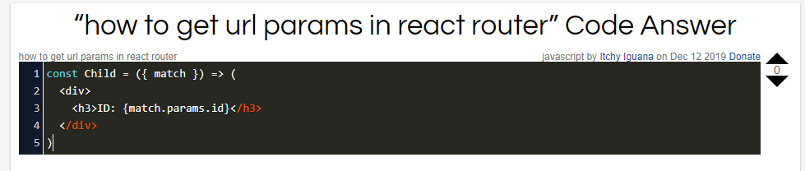

Lets build the productScreen content:

brace yourself , its a long one…

 return (

    <>

      <Link className='btn btn-light my-3' to='/'> //back button

        Back to Products

      </Link>

      <Row>

        <Col>

          <Image src={product.poster} alt={product.name} fluid /> //poster image

        </Col>

      </Row>

      <Row>

        <Col>

          <h1 className='text-center my-5'> //statement centered text

            A NEW KIND OF VOCAL TRANSFORMING PROCESSOR

          </h1>

        </Col>

      </Row>

      <Row>

        <Col>

          <Row className='justify-content-md-center'> //small interface photo centered in its father element (this is the father.)

            <Image src={product.interface} alt='product interface' fluid /> //fluid tag will make it appear as larger as possible

          </Row>

          <Row>

            <Card className='priceCard'> //see index.css for hover effect and pisitioning

              <ListGroup variant='flush'>

                <ListGroup.Item>

                  <Row>

                    <Col className='my-1 text-dark h5'>Price:</Col>

                    <Col className='my-1 text-success h5'>

                      <strong>${product.price}</strong>

                    </Col>

                  </Row>

                </ListGroup.Item>

                <ListGroup.Item>

                  <Row>

                    <Col className='my-1 text-dark h5'>Status:</Col>

                    <Col className='my-1 text-info h5'>

                      {product.status ? ' Available' : 'Coming Soon'}

                    </Col>

                  </Row>

                </ListGroup.Item>

                <ListGroup.Item className='text-center py-0 '>

                  <Button

                    // className='btn-block' //will make it spread all across its div.

                    variant='info'

                    type='button'

                    disabled={!product.status} //if status is false, button is disabled- for coming soon products.

                  >

                    Add to cart

                  </Button>

                </ListGroup.Item>

              </ListGroup>

            </Card>

          </Row>

        </Col>

        <Col>

          <ListGroup variant='flush'> //will take away the border of the list group

            <ListGroup.Item>

              <h2>{product.name}</h2>

            </ListGroup.Item>

            <ListGroup.Item>

              <h4>

                <Ratings value={product.rating} text={product.numReviews} />

              </h4>

            </ListGroup.Item>

            <Card

              style={{

                width: '18rem',

              }}

            >

              <Card.Body>

                <Card.Title>

                  {' '}

                  <strong>Description</strong>

                </Card.Title>

                <Card.Text style={{ fontSize: '1rem' }}>

                  {product.longDescription}

                </Card.Text>

                <Button variant='secondary'>Read more</Button>

              </Card.Body>

            </Card>

          </ListGroup>

        </Col>

      </Row>

      <Row>

        <Col className='text-center my-5'> //text centered

          <h1>FEATURES</h1>

          <ListGroup variant='flush'>

            {product.features.map((feature, i) => ( //don’t forget to use key when iterating a jsx code

              <ListGroup.Item key={i}>

                <h5>{feature}</h5>

              </ListGroup.Item>

            ))}

            <ListGroup.Item>

              <Image src={product.compatibility} alt='compatibility' fluid />

            </ListGroup.Item>

          </ListGroup>

        </Col>

      </Row>

    </>

  )

We will also add code in index.css: for the price card.

.priceCard {

  opacity: 0.6;

  margin-top: 2%;

  width: 13rem;

  position: fixed;

  top: 10%;

  right: 2%;

  z-index: 1;

}

.priceCard:hover {

  opacity: 1;

}

This is how it will look:

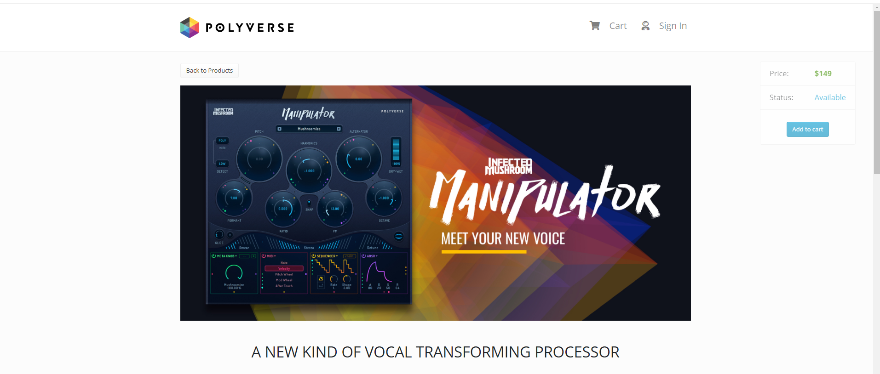

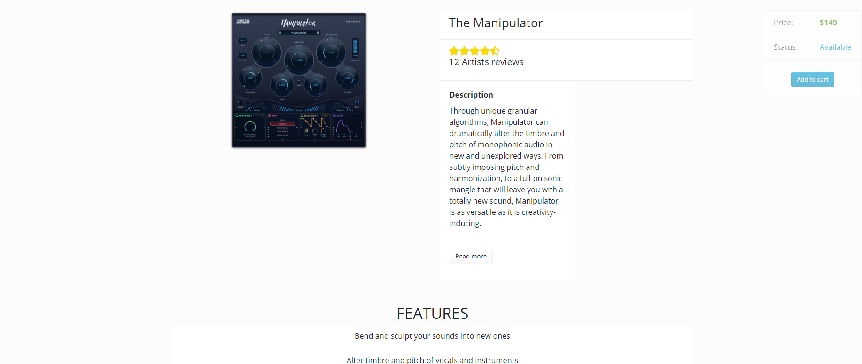

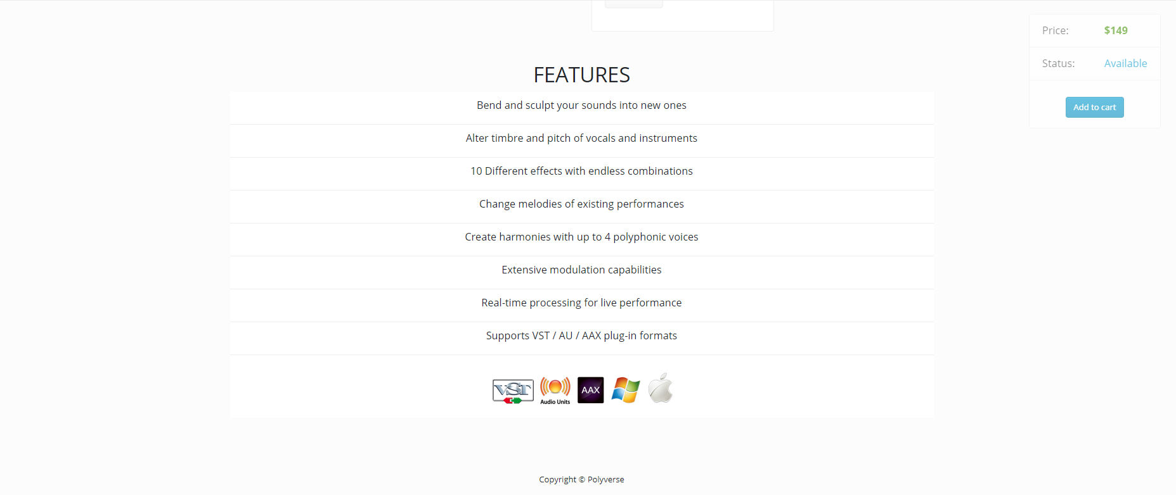

YouTube player component:

<https://www.youtube.com/watch?v=lT4uJI6TXAg&t=607s>

components-> YouTubePlayer.js

YouTube Player API Reference for iframe Embeds:

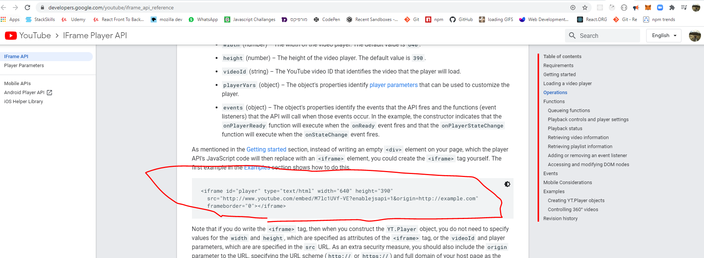

import React from 'react'

const YouTubePlayer = () => {

  return (

    <div className='youtube-player'>

      {/\*snippit from youtube api\*/}

      <iframe

        id='player'

        type='text/html'

        style={{

          width: '100%',

          height: '100%',

        }}

        src='http://www.youtube.com/embed/M7lc1UVf-VE?'

        frameborder='0'

      ></iframe>

    </div>

  )

}

export default YouTubePlayer

draggable component🡺

<https://medium.com/@edwebber06/react-draggable-components-not-such-a-drag-d4fd6098be38>

<https://www.youtube.com/watch?v=lT4uJI6TXAg&t=607s>

make sure you install:

<https://www.npmjs.com/package/react-resizable>

<https://www.npmjs.com/package/react-draggable>

import React from 'react'

import Draggable from 'react-draggable'

import { Resizable, ResizableBox } from 'react-resizable'

import 'react-resizable/css/styles.css'

const YouTubePlayer = ({ videoLink }) => {

  return (

    <Draggable handle='.handle'> //must pass the className of the object that will allow you to drag the div.

      <div

        className='youtube-player'

        style={{ zIndex: 1, paddingBottom: '5%' }}

      >

        <ResizableBox width={300} height={200}> //initial video box size

          {/\*snippit from youtube api\*/}

          <iframe

            title='iframe'

            id='player'

            type='text/html'

            style={{

              width: '100%',

              height: '100%',

            }}

            src={videoLink}

            frameborder='0'

          ></iframe>

          <div

            style={{

              display: 'flex',

              alignItems: 'flex-start',

              justifyContent: 'space-between',

            }}

          >

            <div className='handle'> //this is the icon to drag the video around

              <i className='fas fa-arrows-alt'></i>

            </div>

            <div className='expand'>

              <i className='fas fa-expand-alt'></i>

            </div>

          </div>

        </ResizableBox>

      </div>

    </Draggable>

  )

}

export default YouTubePlayer

index.css🡺

/\*see YouTubePlayer.js ////////////////////\*/

.youtube-player {

  display: flex;

  flex-direction: column;

  justify-content: center;

  align-items: center;

}

.youtube-player .handle {

  position: absolute;

  bottom: -20%;

  right: 95%;

  color: rgb(7, 7, 7);

  opacity: 0.85;

  font-size: 1.5rem;

  cursor: move;

}

.youtube-player .expand {

  position: absolute;

  bottom: -20%;

  left: 95%;

  font-size: 1.5rem;

  color: rgb(7, 7, 7);

  opacity: 0.85;

  cursor: pointer;

}

**Backend-Node.js and express framework, mongo DB and mongoose -object data mapper**

Beckend first setups:

1. Crate a folder in the root 🡺 beckend
2. Initialize package.json and node modules 🡺 go back to the **root** folder and in the **terminal** :  
   >>npm init
3. Press enter, then

Enter project description(=my shop), entry point(= server.js),author(=that’s all you!)

1. Install express 🡺root folder-> >>npm i express

Root folder -> beckend 🡺 new file : server.js (this is the entry point to our server).

1. beckend 🡺 new folder: data, copy to it the products file with the data of each product (Root->frontend-> products.js).
2. \*\*make sure the root level has now 2 new json files: package-lock.json & package.json

notice! **Importing** modules in the **front end** is different than the **back end**.

We don’t use the ***import X from “y”*** syntax (import ES modules)

Rather a ***const X = require(‘Y’)***  - common JS syntax.

But with since Node.js Version 14.4 you may use the ES import module syntax without using Babbel or experimental flag ***server.mjs*** .

(<https://www.youtube.com/watch?v=teDVlOjOCT0> )

beckend->server-> server.js 🡺

1. import express: with common JS syntax
2. set listener on port 5000

const express = require('express')

const app = express()

app.listen(5000, console.log('Hey! server is running on port 5000'))

To test the listener in the terminal go to the root folder by :

>>cd ..

Run the server.js we just created in the backend folder:

>>node backend/server

STORE> node backend/server

Hey! server is running on port 5000

Great. It’s on!

Now instead of running the server like that we can set a shorter script in the

package.json file🡺

we will edit the script section from this:

 "scripts": {

    "test": "echo \"Error: no test specified\" && exit 1"

  },

 "scripts": {

    "start": "node backend/server"

  },

So now to run the server we will only run:

>> npm start

**Some Express methods : .get(), .use(),.listen(),.delete(), .set(), .post() and more…**

Lets make a get request🡺

app.get(path, callback [, callback ...])

Routes HTTP GET requests to the specified path with the specified callback functions.

app.get('/', function (req, res) {

res.send('GET request to homepage')

})

const express = require('express')

const app = express()

app.listen(5000, console.log('Hey! server is running on port 5000'))

app.get('/', function (req, res) { //request or response

//we will response with a send method= this will send the user some data!

res.send(‘this is what you GET when you request this path (/)’)

})

Now we will run the server :

Terminal: >> npm start

On the browser we will go to :

Localhost:5000/

**And we will see the output at the body of the browser!**

**We may also send with is a status method:**

res.status(404).send('Sorry, we cannot find that!')

**but we’ll get to that later. 😊**

Responding an http get request with a product! :

In “Backend first steps” #5 we added the products file to the data folder.

Now look at its content, anything exceptional?

Well… yes.

Backend->Data->Products.js🡺

We need to change its export syntax to module syntax:

module.exports = products

excellent!

Now lets code the response

Backend-> server.js:

const express = require('express')

const products = require('./data/products') //import the product list!

const app = express()

app.get('/', (req, res) => {

  res.send('this is what you GET when you request this path (/)')

})

app.get('/api/products', (req, res) => {

  //lets respond with a product information see backend->data-> products.js

  res.json(products) //.json will sent the data as a JSON format!

})

app.listen(5000, console.log('Hey! server is running on port 5000'))

In the browser:

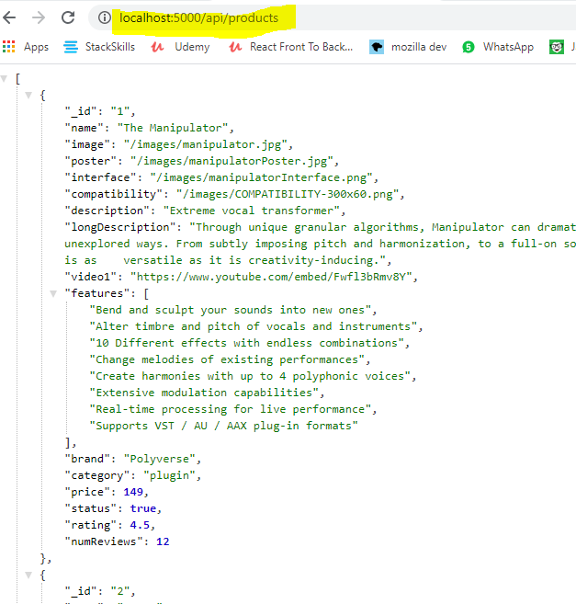

Gaining access to url parameters:

Now lets serve a GET request from the browser => it is asking, by url parameter, a specific product data!

req.params.id 🡺 it allows us check the input in the url under “/:somthingWeLookingFor”

in this case the user id!

app.get('/api/products/:id', (req, res) => {

  //now lets serve a specific product data by url param, user id!

  const product = products.find((element) => element.\_id === req.params.id)

 //find the product in the products array with the id in the url

 res.json(product) //.json will sent the data as a JSON format!

})

In the browser:

We will run the server again >>npm start

And in the url ask for user with id === 1

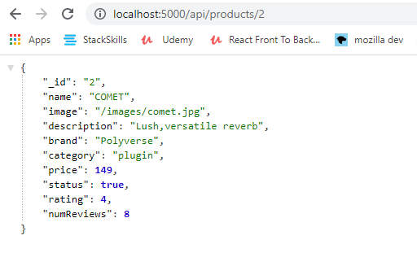

Serve data from the server by requesting it in the frontend!

\*\*you should be familiar with:

***the fetch API***

**fetch (‘url’ , {option} ).then(res=> return res.json() ).then(data => console.log(data) ).catch(error)**

**option🡺 {method: ‘POST’ , headers: {‘Content-Type’ : ’application/json’} ,body: JSON.stringify({name : ’User 1’})**

* **you must stringify the body!!**
* **POST** 🡺 **adding data to the server.**
* **fetch** 🡺 **returns a promise. (so we can use async await or then().catch**
* **first then** 🡺 **returns the response object, its containing a body ,headers, status (200,404 and so on…) the body who is actually containing our data is not accessible. We must convert the response to json! => we do it by : res.json()=> which will return the data in the body BUT in another promise!! So we should use again another then.**

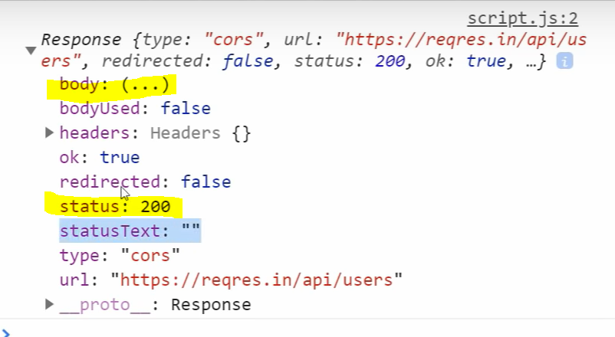

* **second then** 🡺 **returns the data itself.**
* **Catch statement: will return an Error only in the case of connection to url failure.**
* **In order to catch a 404 error (when trying to get a data that does not exists in the DB you must add in the first then statement : if (res.ok){}else{ console.log(error)}**

<https://www.pluralsight.com/guides/axios-vs-fetch>

<https://dev.to/shoupn/javascript-fetch-api-and-using-asyncawait-47mp>

async function getUserAsync(name)

{

let response = await fetch(`https://api.github.com/users/${name}`);

let data = await response.json()

return data;

}

getUserAsync('yourUsernameHere')

.then(data => console.log(data));

Lets start!

**Make sure your backend server is running!**

Terminal 1-> cd .. (to root folder)-> >>npm start (on port 5000)

**Open a new terminal and run the front end dev server :**

Terminal 2-> cd .. (to root folder)->>>cd ./frontend

Add **axios** to your project:

its an http requests library to make requests to the server.

You may also use the fetch API

Terminal 2-> >>cd ./frontend -> npm i axios

>> npm start to launch

HomeScreen.js🡺

**Although the products will soon be handled by redux as app level.**

**For now** the products will be a **local state** in the home screen page using **the useState HOOK**!

**useEffect** runs as soon as the component load=> will enable us to request the products from the server via fetch! (or axios, in our case)

syntax : useEffect( ()=>{…}, [dependencied])

dependencied- variables that when changed, will cause the useEffect to run again.

\*notice we didnt set a proxy yet, but wait…

import React, { useState, useEffect } from 'react'

import { Row, Col } from 'react-bootstrap'

import axios from 'axios'

// import products from '../products' at first we brought the data from a js file.

import ProductCard from '../components/ProductCard'

const HomeScreen = () => {

  const [products, setProducts] = useState([]) // initial state is an empty array, because the product list is an array of objects (products).

  useEffect(() => {

    //will run as soon as this component mounts!

    const fetchProductsServer = async () => {

      //the data has been sent as json from  server.js (app.get...)

      const response = await axios.get('/api/products')

      const data = await response.data //no need to use .json() method to pase the data , its already parsed by axios.

      console.log(response)

      console.log(data)

      setProducts(data) //connecting the state to data ==> products will be  equal to data

    }

    fetchProductsServer() //calling the function to fetch the products!

  }, [])

  return (

    <>

      <h1> Our Products </h1>

      <Row>

        {products.map((product) => (

          <Col sm={12} md={5} lg={4} xl={3} key={product.\_id}>

            <ProductCard product={product} />

          </Col>

        ))}

      </Row>

    </>

  )

}

export default HomeScreen

Set a proxy:

When you will will try to run the code you will get an error in the console. the GET methot you ran on the server when you tried to fetch the data === axios.get('/api/products') === failed!

server.js

app.get('/api/products', (req, res) => {

  //lets respond with a product information see backend->data-> products.js

  res.json(products) //.json will sent the data as a JSON format!

})

It’s currently looking for the data in the frontend dev server and not the express server we set on port 5000!

Frontend/Package.json.json🡺

\*notice on deploy it will change!

{

  "name": "frontend",

  "proxy": "http://127.0.0.1:5000", //just write it beneath name …

  "version": "0.1.0",

  "private": true,

  "dependencies": {

    "@testing-library/jest-dom": "^4.2.4",

    "@testing-library/react": "^9.5.0",

    "@testing-library/user-event": "^7.2.1",

    "axios": "^0.20.0",

    "react": "^16.13.1",

    "react-bootstrap": "^1.3.0",

    "react-dom": "^16.13.1",

    "react-draggable": "^4.4.3",

    "react-resizable": "^1.11.0",

    "react-router-bootstrap": "^0.25.0",

    "react-router-dom": "^5.2.0",

    "react-scripts": "3.4.3"

  }, //there is more data..

Re run the frontend wed dev server :

>> npm start

And products should be loaded from the beckend server.

In the browser check the network tab:

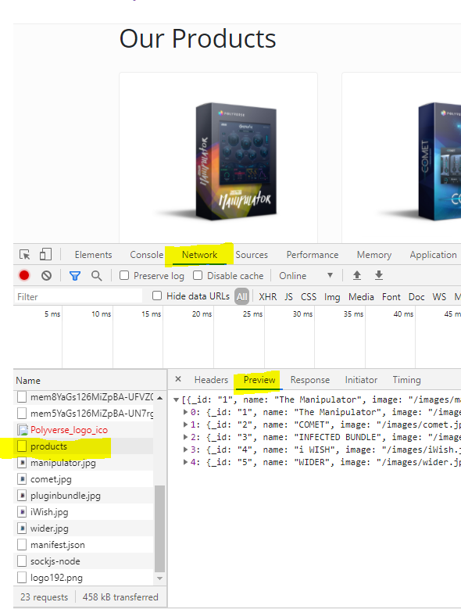

Now lets do the same process in the product page:

Server.js 🡺 remember ?

app.get('/api/products/:id', (req, res) => {

  //now lets serve a specific product data by url param, user id!

  const product = products.find((element) => element.\_id === req.params.id)  // matching the user in the DB to the one being asked in the url parameter.

  res.json(product) //.json will sent the data as a JSON format!

producstScreen.js🡺

import React, { useState, useEffect } from 'react'

import { Link } from 'react-router-dom'

import { Row, Col, Image, ListGroup, Card, Button } from 'react-bootstrap'

import Ratings from '../components/Ratings'

//import products from '../products' //its not a react component but a js variable

import YouTubePlayer from '../components/YouTubePlayer'

import axios from 'axios'

const ProductScreen = (props) => {

  //we use props.match!

  const [product, setProduct] = useState({}) // initial state is an empty object, because product is an object.

  useEffect(() => {

    const fetchProdFromDB = async () => {

      //props.match.params.id allow us to get the params passed in the frontend's url !

      const response = await axios.get(`/api/products/${props.match.params.id}`)

      const data = await response.data

      console.log(data)

      setProduct(data) //setting the local state

    }

    fetchProdFromDB()

  }, [])

**That it! Now the product page should run while fetching the product data from the server based on id in the url.**

Install Nodemon & concurrently & running client server (frontend).

Install As dev dependencies.

**Nodemon- restarting automatically the backend server on update.**

**At root folder:**

**>> npm i -D nodemon concurrently**

**Now lets write a script for initializing nodemon:**

**At root folder package.json. json 🡺**

 "scripts": {

    "start": "node backend/server",

    "server": "nodemon backend/server",

    "client": "npm start --prefix frontend",

    "dev": " concurrently \"npm run server\" \"npm run client\""

  },

**"client": "npm start --prefix frontend" 🡺 frontend is the name of the folder that will run.**

**When using >> npm run client .**

**Meaning we can run the frontend dev server now from the root folder.**

**Also : >>npm run server**

**Meaning we can run the backend dev server now from the root folder and it will refresh automatically when backend changes.**

**>>npm run dev //is a concurrently feature which allow us to run both simultaneously**

Environment variables

One of the famous environment variables is the process.env.PORT (also API keys ):

Right now we are using port 5000 manually.

But when we will connect a DB with our code and deploy it we will have to get it using the

process.env.PORT method.

\*\*API keys – whether a paid or free one it is very important as a security measure to set them as ENV variables.!

\*\*secret tokens as well (we’ll get to that later).

Some environment variables are changing from one operating system to another browsers etc.…

dotenv - an npm package that loads environment variables from a .env file into [process.env](https://nodejs.org/docs/latest/api/process.html" \l "process_process_env). Storing configuration in the environment separate from code is based on [The Twelve-Factor App](http://12factor.net/config) methodology.

Lets install it:

At root level-

> npm i dotenv

CREATE A NEW .env FILE AT ROOT LEVEL:

IN IT SET TWO ENV VARIABLES, AT THIS EXACT SYNTAX!

ROOT-> .env 🡺

\*\*make sure it’s in the .gitignore file as well!!!

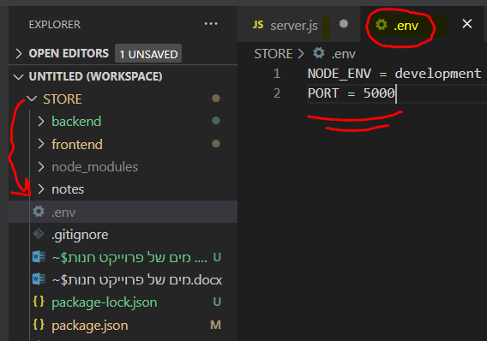

\*NODE\_ENV will soon be interactive, it could be also be production mode

Backend/server.js 🡺

const express = require('express')

const dotenv = require('dotenv') //

const products = require('./data/products')

const app = express()

dotenv.config() //

const PORT = process.env.PORT || 5000

const mode = process.env.NODE\_ENV

{ . . .}

app.listen(

  PORT,

  console.log(`Hey! server is running in ${mode} mode on port: ${PORT}`)

)

Changing backend import expression to ES modules

Check node.JS documentation: (you should have at least V14.3)

<https://nodejs.org/dist/latest-v14.x/docs/api/packages.html#packages_type>

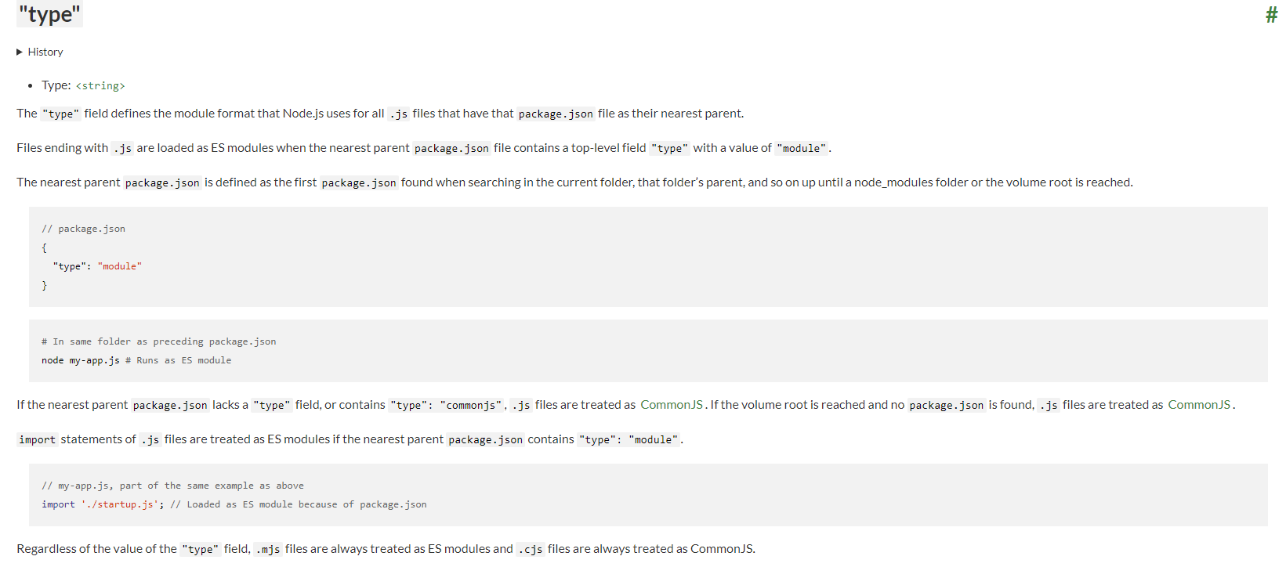

package.json on root level (backend)

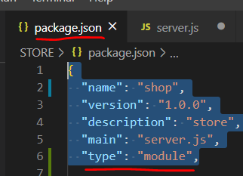

\*The tradeoff of using the ES module syntax is that you must mention the file’s type : **.js**

Backend->data->product.js🡺

Now we must change the export syntax…

export default products

connecting the project to a Database (DB)

**mongoDB: no sql DB**

**Collection and documents:**

**Each document is basically a json file – format**

**For instance: products == collection , product X == document.**

**Users==collection, user X == document.**

**Orders… and so on..**

* **Compass- desktop (Graphical User Interface) GUI for interacting with the data IN THE db. DOWNLOAD IT AND INSTALL ON YOUR PC.**
* **Atlas- cloud DB. GO TO🡺 cloud.mongodb.com, AND START A NEW PROJECT / CLUSTER. FOR FREE!**

**Security measures in Atlas before connecting the two:**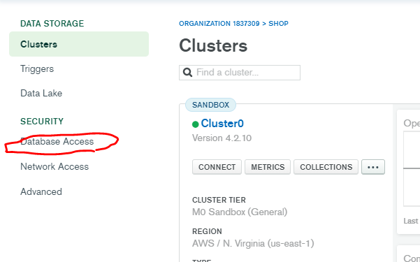

**Add a new DB user:**

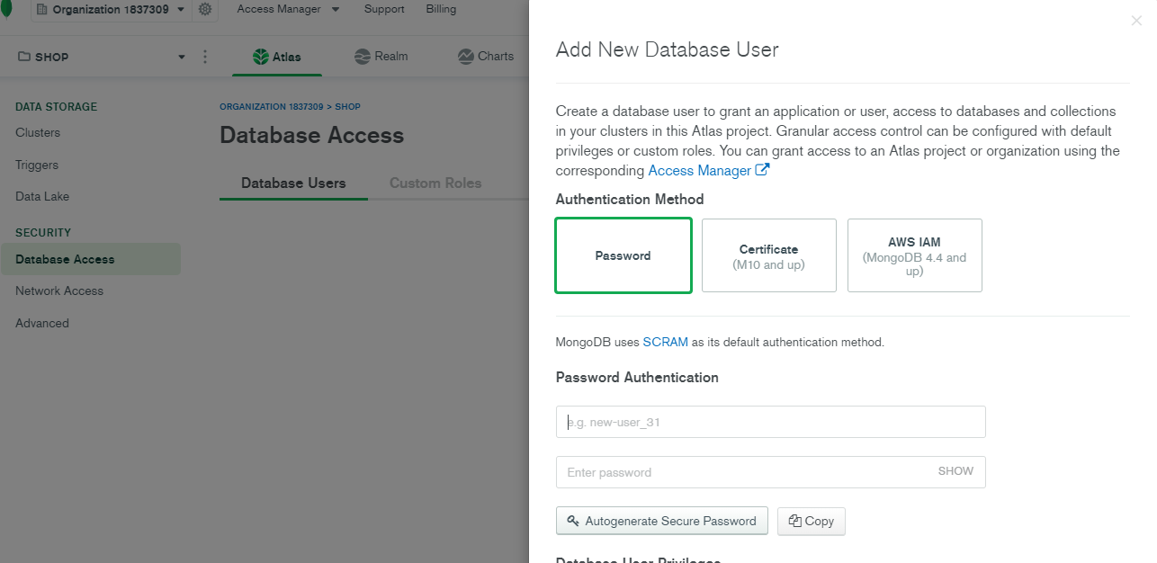

**Choose user name and password.**

**network access**

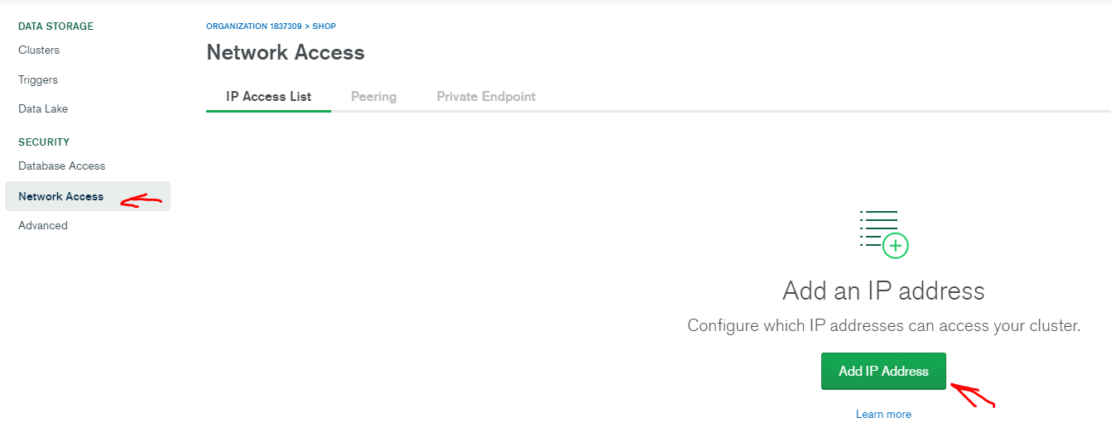

**Add your current IP address**

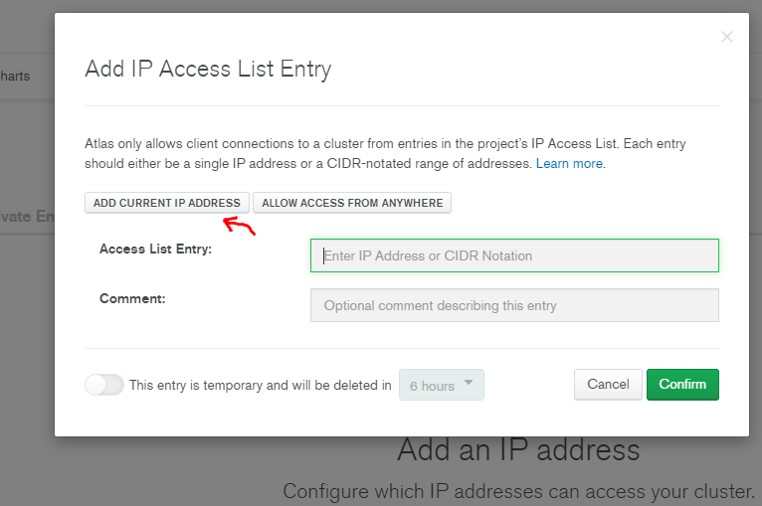

**Go back to clusters**

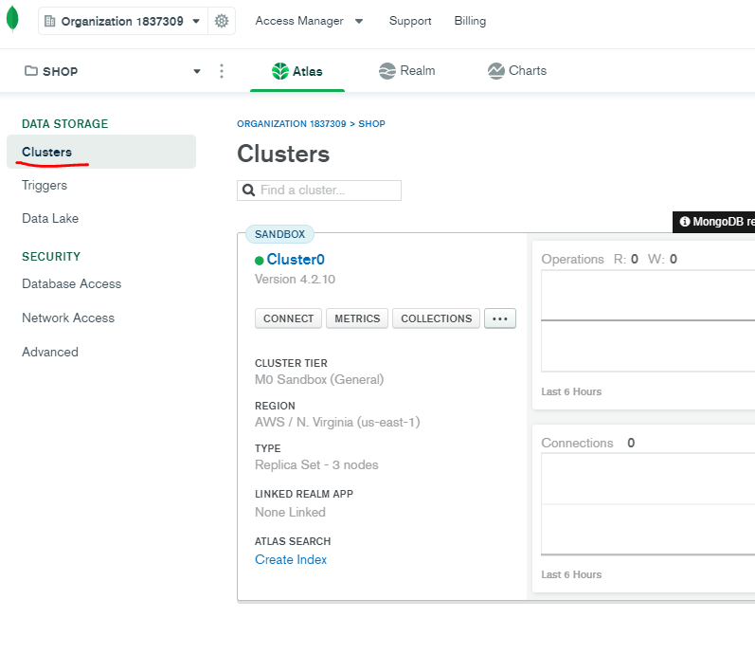

**Click on: collections -> click on: Add my own database->  
choose your DB name and a collection name your app will have (just one for now)**

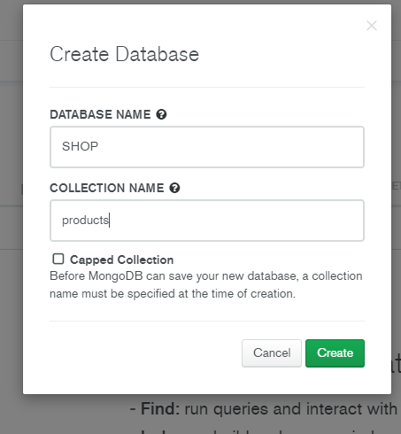

**Now go back to the clusters main page and click Connect!**

**Then click connect to compass (later we will click connect to application)**

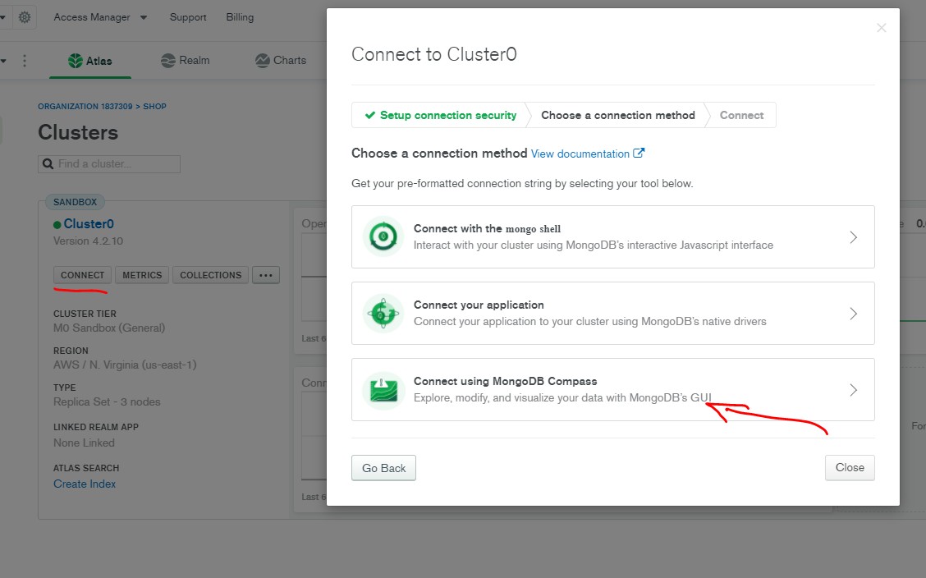

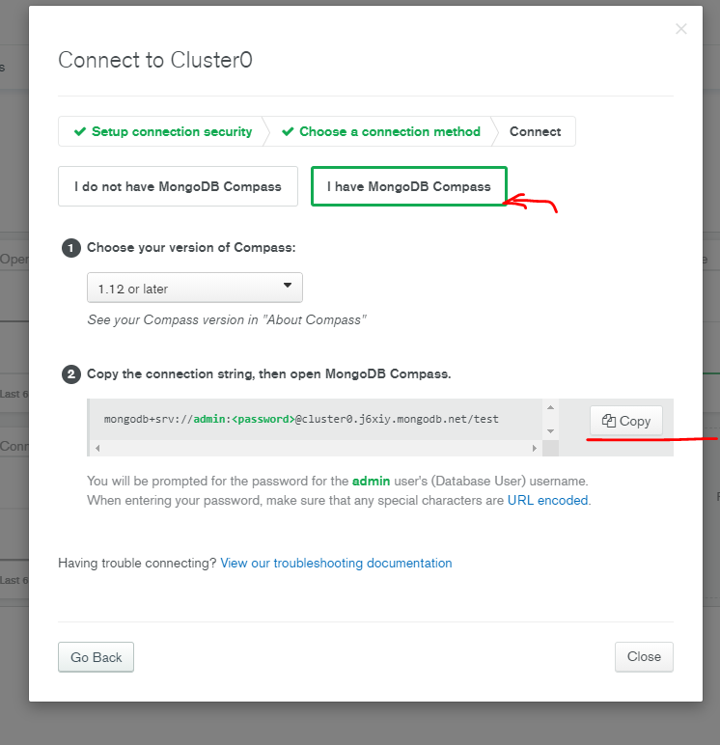

**Copy the connection string**

**Connect compass and alas: we will use a connection string we just copied**

**Compass:**

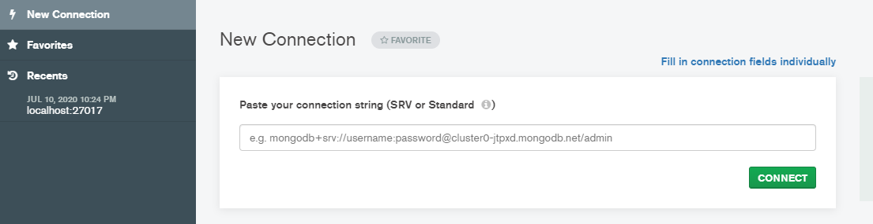

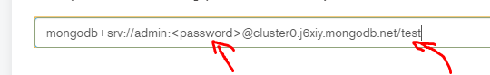

**Make sure you add your password and dich the <>, instead of test write the name of your DB name.**

**Click connect, and that’s it! The two are paired!**

**Now we need to connect the app itself to the DB:**

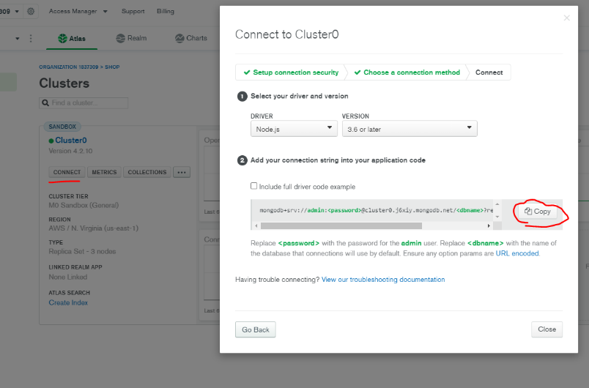

**The string we just copied will be added to the .env file under MONGO\_URI:**

**MONGO\_URI = mongodb+srv://admin:\*\*\*password here\*\*\*@cluster0.j6xiy.mongodb.net/\*\*DB NAME HERE\*\*?retryWrites=true&w=majority**

**the next step is to use mongoose- an object data modelling for Node.js that allows us to interact with our DB, create & find data.**

**Terminal->**

**Root folder level:**

**>> npm I mongoose**

**Backend-> create a new folder: config -> in it create a file: db.js 🡺**

**This is the file which serve as a database connection. It will look like this:**

import mongoose from 'mongoose';

const connectDB =  async ()=>{

    try{

        const conn = await mongoose.connect(process.env.MONGO\_URI,{

            //must add in order to not get any error masseges:

            useUnifiedTopology:true,

            useNewUrlParser: true,

            useCreateIndex: true

        })

        console.log(`mongo database is connected!!! ${conn.connection.host} `)

    }catch(error){

        console.error(`Error: ${error} `)

        process.exit(1) //passing 1 - will exit the proccess with error

    }

}

export default connectDB

**backend-> server.js 🡺 add two lines**

import express from 'express'

import dotenv from 'dotenv'

import connectDB from './config/db.js' // DB connection

import products from './data/products.js'

dotenv.config()

const PORT = process.env.PORT || 5000

const mode = process.env.NODE\_ENV

const app = express()

connectDB() //this function connects us to the DB!!!

. . . more code…

**Important note!!! Make sure connectDB() is after dotenv.config!!!**

**that’s it! We are connected to the DB.**

**You can check it by root folder terminal**

**>> npm run server**

**Colorize the termina outputs:**

**(\*Not a must – before you run the server install >>npm i colors 🡺 will color the terminal outputs)**

<https://www.npmjs.com/package/colors>

console.log('hello'.green); *// outputs green text*

console.log('i like cake and pies'.underline.red) *// outputs red underlined text*

console.log('inverse the color'.inverse); *// inverses the color*

console.log('OMG Rainbows!'.rainbow); *// rainbow*

console.log('Run the trap'.trap); *// Drops the bass*

**you may add it in db.js & server.js :**

**server.js🡺**

app.listen(

  PORT,

  console.log(`Hey! server is running in ${mode} mode on port: ${PORT}`.yellow.bold)

)

**Terminal🡺**

**Hey! server is running in development mode on port: 5000**

**Data modeling**

Backend-> create a new folder: **models🡺**

**We will create 3 models : userModel.js , productModel.js , orderModels.js**

each file will contain a schema: the structure of each object in the data base.

And a MODEL- constructed from the schema and a name of model.

The model variable name is what being exported from each file.

import mongoose from 'mongoose';

const userSchema = mongoose.Schema({

    name:{

        type: String,

        required: true

    },

    email:{

        type: String,

        required: true,

        unique: true

    },

    password:{

        type: String,

        required: true

    },

    isAdmin:{

        type: Boolean,

        required: true,

        default: false

    }

},{

    //mongoose built in time stamps for "created at"/ "updated at"

    timestamps: true

})

const User = mongoose.model('User', userSchema) //model is constructed from the schema and the name ‘User’

export default User

Product schema contains also the review schema.

import mongoose from 'mongoose';

const reviewSchema = mongoose.Schema({ //a single review schema may also be in its own file ...

    name:{

        type: String,

        required: true

    },

    rating:{

        type: Number,

        required: true

    },

    comment:{

        type: String,

        required: true

    },

},{ //mongoose built in time stamps for "created at"/ "updated at"

timestamps: true })

const productSchema = mongoose.Schema({

    user:{ //who created the product?

        type: mongoose.Schema.Types.ObjectId,

        required: true,

        ref: 'User' //will create relations between the productModel and userModel (the one who added the product)

    },

    name:{

        type: String,

        required: true

    },

    image:{

        type: String,

        required: true,

    },

    brand:{

        type: String,

        required: true

    },

    category:{

        type: String,

        required: true

    },

    description:{

        type: String,

        required: true

    },

    rating:{

        type: Number,

        required: true,

        default:0

    },

    reviews:[

        reviewSchema

    ],

    numReviews:{

        type: Number,

        required: true,

        default:0

    },

    price:{

        type: Number,

        required: true,

        default: 150

    },

    inStock:{

        type: Boolean,

        required: true,

        default: true

    },

},{

    //mongoose built in time stamps for "created at"/ "updated at"

    timestamps: true

})

const Product = mongoose.model('Product', productSchema)

export default Product

import mongoose from 'mongoose';

const orderSchema = mongoose.Schema({

    user:{ //who created the product? //will create relations between the productModel and userModel-> (the one who buys the product)

        type: mongoose.Schema.Types.ObjectId,

        required: true,

        ref: 'User'

    },

    orderItems:[{

        name:{type: String, required:true},

        quantity:{type: Number, required:true},

        image:{type: String, required:true},

        price:{type: Number, required:true},

        product:{//will have relations with the product schema

            type: mongoose.Schema.Types.ObjectId,

            required: true,

            ref: 'Product'

        }

    }],

    shippingAddress:{

        adress:{ type: String, required:true },

        city:{ type: String, required:true },

        postalCode:{ type: String, required:true },

        country:{ type: String, required:true },

    },

    paymentMethod:{

        type: String,

        required: true,

    },

    paymentResult:{ //will be recieved from paypal...

        id: {type: String},

        status: {type: String},

        update\_time: {type: String},

        email\_address: {type: String},

    },

    taxPrice:{

        type: Number,

        required: true,

        default: 0.0

    },

    shippingPrice:{

        type: Number,

        required: true,

        default: 0.0

    },

    totalPrice:{

        type: Number,

        required: true,

        default: 0.0

    },

    isPaid:{

        type: Boolean,

        required: true,

        default: false

    },

    paidAt:{

        type: Date

    },

    isDelivered:{

        type: Boolean,

        required: true,

        default: false

    },

    deliveredAt:{

        type: Date

    },

},{

    //mongoose built in time stamps for "created at"/ "updated at"

    timestamps: true

})

const Order = mongoose.model('Order', orderSchema)

export default Order

adding product data to database

backend->data->products.js 🡺

each product has an \_id: property , we need to delete it because when adding data to monogo it’s automatically generates an id.

backend->data-> add a new file: users.js🡺

in it we will create 3 user ,one of them is the admin:

const users = [

    {

        name: 'Admin',

        email:'orisouchami1@gmail.com',

        password: xxxx, //just a placeholder for now, we need to hash it in

 the DB.

        isAdmin: true

    },

    {

        name: 'joe',

        email:'joe@gmail.com',

        password: xxxx,

    },

    {

        name: 'john',

        email:'john@gmail.com',

        password: xxxx,

    }

]

In order to encrypt we will install bcryptjs:

Terminal at root level:

>>npm i bcryptjs

import bcrypt from 'bcryptjs'

const users = [

    {

        name: 'Admin',

        email:'orisouchami1@gmail.com',

        password: bcrypt.hashSync('Shopadminori1',10), //hash the pasword you entered when you set the admin user in mongo

        isAdmin: true

    },

    {

        name: 'joe',

        email:'joe@gmail.com',

        password: bcrypt.hashSync('123456',10),

    },

    {

        name: 'john',

        email:'john@gmail.com',

        password: bcrypt.hashSync('123456',10),

    }

]

export default users

Database Seeder:

Seeding a database is a process in which an initial set of data is provided to a database when it is being installed. It is especially useful when we want to populate the database with data we want to develop in future.

Backend-> create a new file: seeder.js🡺

A separate script we will run in order to import data!